

**10. CUP of KOPER 2025**

**Invitation to the international Surf ski and SUP race**

Dear sport friends,

we invite you to the international Cup of Koper race in Surf ski and SUP - downwind categories.

# Date

The race will be held in a window of 2 days, Saturday, 4. 10. 2025 or Sunday, 5.10. 2025 - depending on the best downwind conditions. The exact date will be published 5 days before the race on [www.kajak-zveza.si.](http://www.kajak-zveza.si/)

# Regatta field

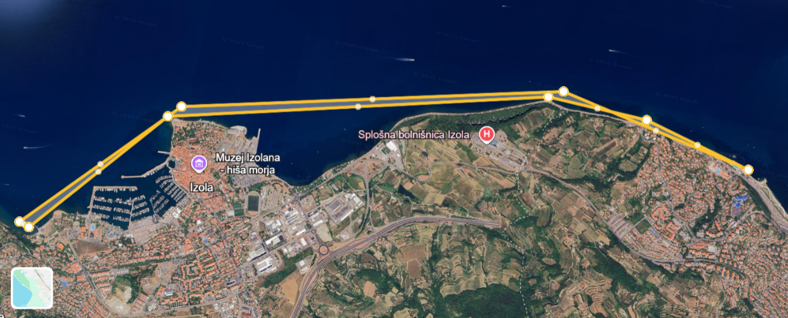

The start and finish of the competition will be in Žusterna, the course will be along the coast, past Izola to San Simon bay.

The course will be in the form of a line and will not be marked. The turn with one buoy and the start-finish line will be marked

**Canoes allowed :**

All type of kayak boats. Wildwater, sprint, SS1 - Men/Women (open category). All types of SUPs are allowed (open category).

**Categories:**

* Juniores, M/W
* Seniores, M/W
* Veterans, M/W

# Programme

9.00-10.00 Registration of the competitors, bib and maps delivery at Žusterna Kayak

club.

9.30 Team leaders meeting KKK Žusterna

11.00 Start of the competition at the KKK Žusterna or Bernardin marina

14.00 Prize giving ceremony at KKK Žusterna

**Security and equipment**

All participants must declare that they are free of any physical troubles and that they are able to cover high physical demand for about 5 hours. Also every participant must declare that he/she is experienced in paddling at open sea conditions. Every participant has to agree and sign the liability waiver that will be found in the registration.

Safety is guaranteed with 5 boats. All participants have to use their own equipment, which has to be in secured and fully usable conditions, so it will not become a danger in using it, either for the participants or the organization. Also in addition all participants must have the experience to be able to complete the distance in open sea conditions. The organization reserves the right to deny any participant to start a race, if the organization has the impression or there are obvious signs that either the participant or material is not able to finish the race, without a payback of the registration fee.

The following items are mandatory:

Technically proper equipment. Life vest must be worn. Leash must be worn.

We advise participants to have a GPS and mobile in the water resistant bag. Very near the start location it will be possible to use the clothes storage and changing room.

**Entry fee**

Entry fee will be 15 Euros per person.

**Medals**

Medals will be given to best 3 in each category.

# Entries

We ask competitors to contact organizers and make entries before **1.10.2025**

via E-mail: kkk_zusterna@hotmail.com or post address:

Kajak kanu klub Žusterna, Istrska cesta 70, Koper Slovenia

# Accommodation and general information

Car parking will be possible near the competition location.

Hot drinks will be available for the competitors near the Start- Finish position.

For accommodation please contact:

**T:** +386 (0) 5 664 64 03 **F:** +386 (0) 5 664 64 06

**E:** tic@koper.si

**W:** [www.koper.si](http://www.koper.si/)

**LEADER OF COMPETITION**

Zdenka Ponomarenko